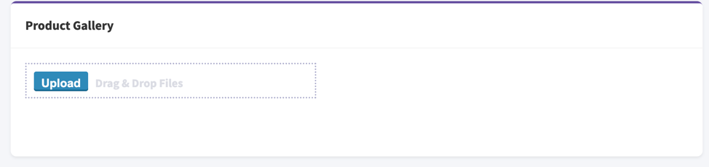
Can we allow the user to access the media of the site itself and another option to upload from the computer.
As of now when we click upload it automatically redirects us to the computer storage

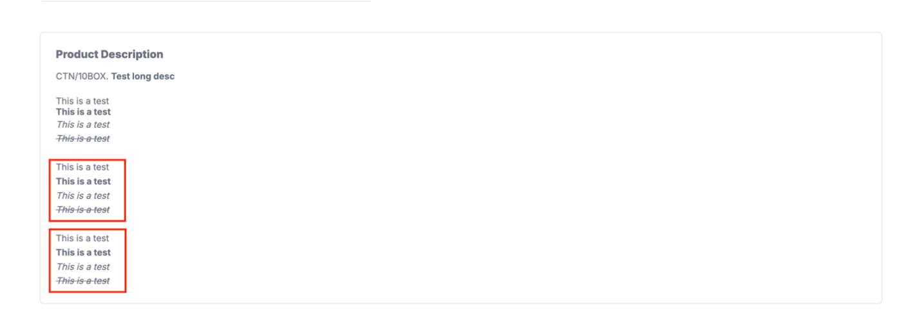
Bullets and Numbering is not working

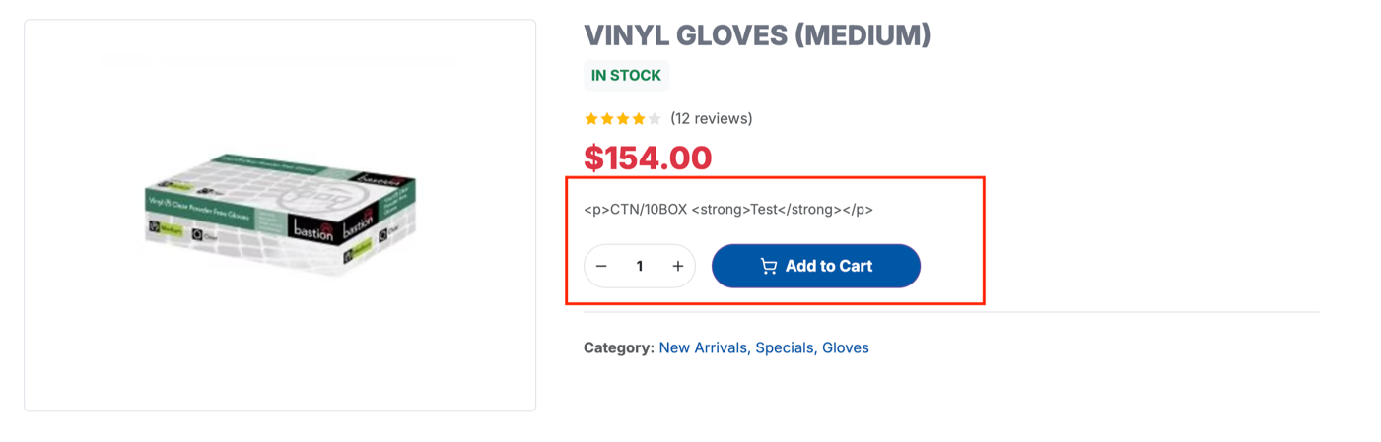
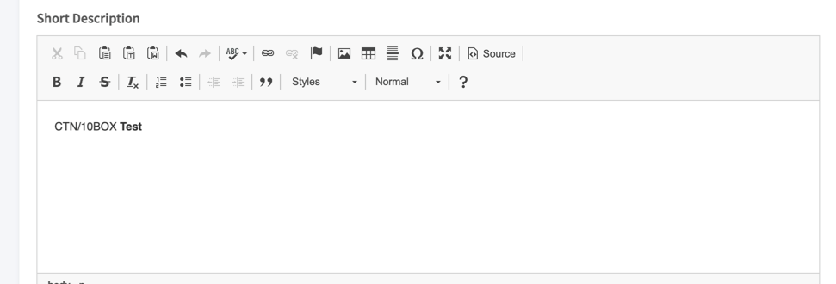
Rather than the normal text, it’s showing us the HTML version..

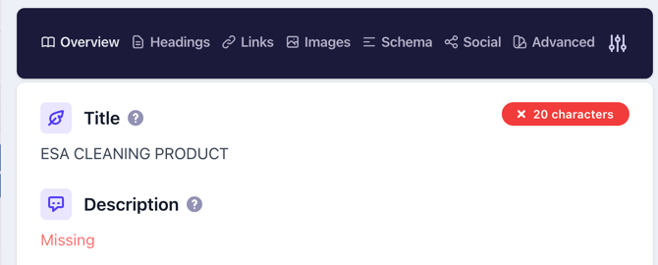
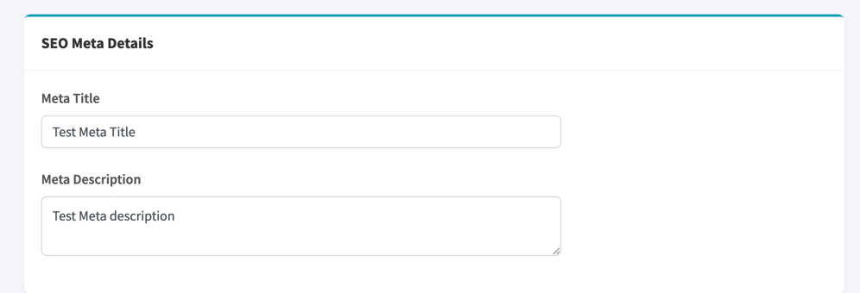
Not Pulling the meta data

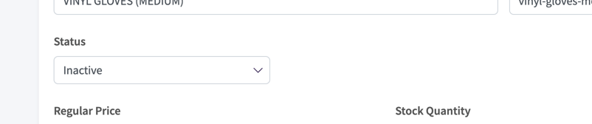
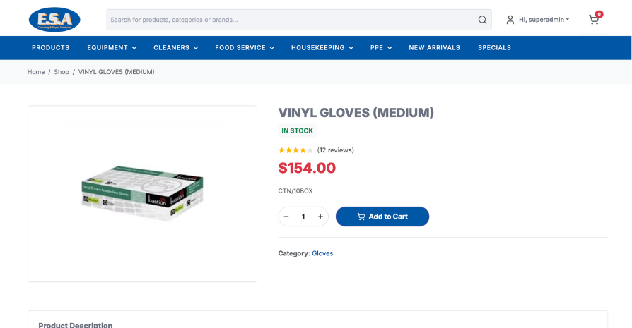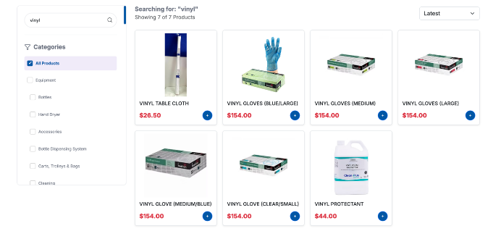

Even after the status is inactive, the product is still showing in the frontend

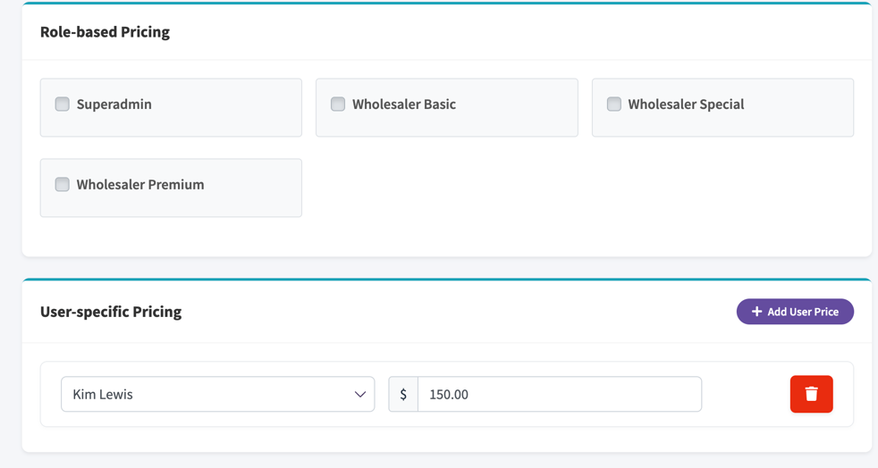
Use of these buttons: ???
Not working…

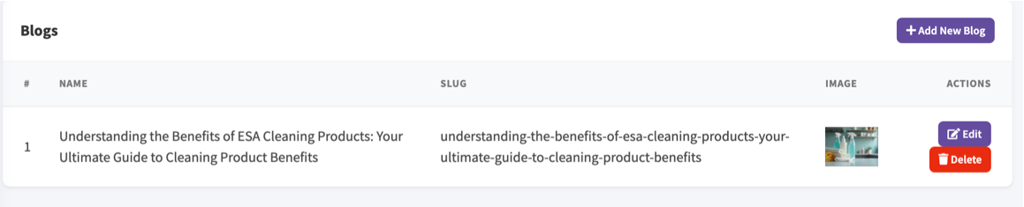
Need a blog preview button, inside the main page and outside the listing page.
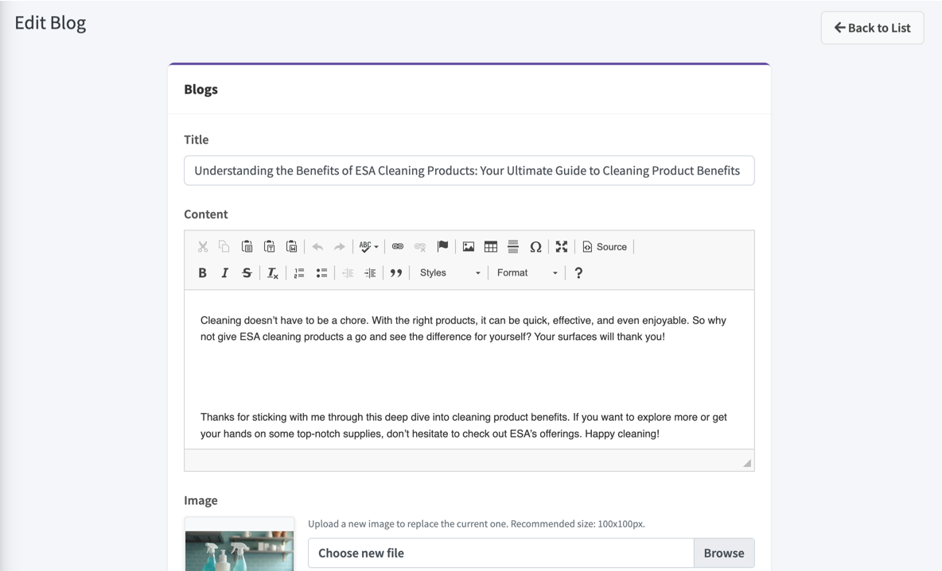
Need status button, to active, inactive.


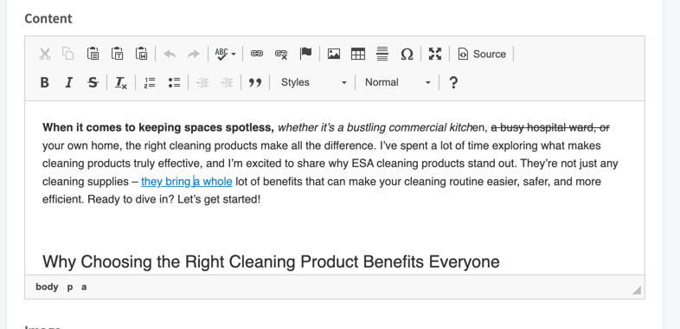

Make the text with link highlighted with the brand primary colour.

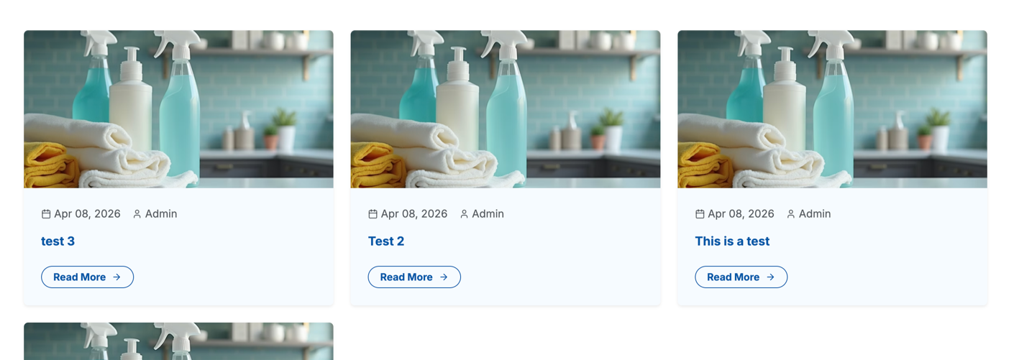
Feature Image is getting cut from the above. Need a container which can adjust any image, in the thumbnail

